

Ashley Furniture Industries, LLC. - Ashley Distribution Services, Ltd. - Ashley

Application Document
Surcharge UI/Data Sync/ Microservice

Project Title: Surcharge UI/ Data Sync/ Microservice
Dev Ops Epic: CI - 2024 Q3 & Q4 - Pricing -
Dev Ops Epic Link: EPIC 1194258
Dev Ops Feature: CI - Adjustment Microservice
Dev Ops Feature Link: FEATURE 1276263

Version: 1.1

Revision History

Version # | Change Implementation Date | Detailed Description | Change Request Number | Reference Section page Number | Author
1.0 |  | Implementation of Adjustment microservice for surcharge project | CHG0038689,  CHG0038903,  CHG0039158
1.1 |  | Implementation of PIM Product Data API for Adjustment microservice | CHG0041582
1.2 |  | Configuring the windows job to update the PIM Product Details | CHG0041919
 |  | Implementation of Adjustment microservice on Kubernetes and Adjustment Details API for surcharge project | CHG0043438
 |  | Production promote of Adjustment UI Changes in Ashley Net Application | CHG0043667
 |  | Production promote of PIM API and windows job scheduler | CHG0043746

How to Update the Table of Contents:
- Click anywhere in the Table of Contents to select it (it becomes grayed when selected).
- The Update Table dialog box appears in the upper left corner of the table:
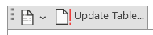
- Click on Update Table and The Update Table of Contents dialog box appears:
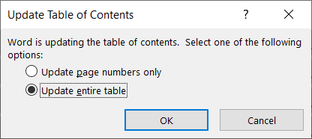
- Choose Option 1 to Update page numbers only if none of the headings have changed, but just the page numbers; OR choose option 2 to Update the entire table if more substantial changes were made to your document – such as headings that were added or removed, or additional paragraphs that were formatted with heading styles for inclusion in the Table of Contents.
- Click OK.

Introduction

Introduction
With global container shipping capacity reduced by 30%, freight rates have surged, threatening profit margins on imported goods. To counter this, a dynamic Import Surcharge mechanism is proposed. This solution ensures that surcharges are applied fairly and visibly across both new and open orders, with centralized control and customer-level flexibility.

Core Functionalities
1. Global & Customer-Level Management
Global Configuration: Centralized surcharge settings by Item Class.

Customer Overrides: Ability to exclude customers or apply custom surcharge percentages.

2. Surcharge Table & Item Class Mapping
A dedicated surcharge table maps applicable Item Classes to:

Surcharge percentage (x%)

Effectivity dates (based on order date)

Future-ready for additional levels: Sales Class, Warehouse, Item, etc.

3. Calculation Logic
Line-Item Based: Surcharge = Unit Price × % Surcharge

Rounding: Rounded up to the nearest dollar.

Quantity Handling: Extended based on quantity ordered.

Live Recalculation: Until shipment/invoicing, surcharge is recalculated dynamically.

Non-Commissionable & Non-Taxable: By default, with future options to enable both.

4. Invoice Presentation
Machine-to-Machine: Surcharge is rolled into the line-item price.

Human-Readable: Surcharge appears as a separate line item for clarity.

5. Future-Proofing

Support for:

Flat rate, cube, or weight-based surcharges

Invoice-date-based effectivity

Recalculation triggers for open orders

Refundable surcharges

Commissionable and taxable options

Order-level surcharge aggregation
- Manual Trigger Urls:
  - Dev: https://adjustment-microservice.dev.finance.ashleyfurniture.com/Adjustment/Orders

  - Stage: https://adjustment-microservice.stage.finance.ashleyfurniture.com/Adjustment/Orders

  - Prod: https://adjustment-microservice.prod.finance.ashleyfurniture.com/Adjustment/Orders

Sample Input:

{
"orders": [
{
"order_id": "2345",
"customer_id": 2307300,
"ship_to": "01",
"order_date": "2025-06-12T00:00:00Z",
"est_ship_date": "2025-05-31T14:00:00Z",
"invoice_date": "2024-06-28T09:00:00Z",
"warehouse_id": "335",
"items": [
{
"item_id": "B044-26",
"quantity": 1,
"price": "10.00"
}
]
}
]
}

Screenshots, Out of the Surcharge

{
"orders": [
{
"order_id": "2345",
"customer_id": 2307300,
"ship_to": "01",
"total_surcharge": 1.00,
"adjustments": [
{
"item_id": "B044-26",
"quantity": 1,
"price": 10.00,
"status": "2",
"adjustment_details": [
{
"credit_code": "TSC",
"adjustment_name": "TSC TSC SURCHARGE SALES - TEST",
"adjustment_amount": 1.00,
"invoice_level": "1",
"taxable": "N",
"commissionable": "N",
"calculation_value": 1.5000,
"calculation_type": "PERCENT",
"applied_level": "ITEMCLASS",
"applied_level_value": "ZDYB",
"charge": true,
"quantity": 1,
"price": 10.00
}
]
}
]
}
]
}

Stored PROC which handles the surcharge

CREATE procedure [dbo].[usp_GetAdjustmentAmount_v7]
(
@AdjustmentRequests AdjustmentRequestType READONLY
)
AS
/**********************************************************
Procedure Name: [usp_GetAdjustmentAmount_v7]
Database: Surcharge
Reason Created : Calculates the surcharge from customer override first if not then will take it from Adjustment Detail
Author: Ranjith M
Changed by: Damodharan R
Owned By: Pricing
Used By: Pricing
Used For: Pricing
Date Created: 12/1/2024
Change done on : 27/1/2024
Object(s) Used: tblItemList, tblAdjustmentCustomerOverride, tblAdjustmentDetail, tblAdjustmentHeader,tblAdjustmentItemExclusion
Change done on : 04/28/2025
Updated By : Damodharan R
Changes : Excluded Warehouse
Change done on : 05/08/2024
Updated By : Damodharan R
Changes : Warehouse added for customer override

Sample Execute :
DECLARE @AdjustmentRequests AS AdjustmentRequestType;
INSERT INTO @AdjustmentRequests (ItemNumber, StartDate, CustomerId, CustShipTo, Price, Quantity,Warehouse)
VALUES
('W549-68', '2025-04-23', 1059900, '38', 63.00, 1,1)
, ('W648-68', '2025-04-23', 193300, '85', 63.00, 1,5)
EXEC [usp_GetAdjustmentAmount_v7] @OrderItems

Change# Last Modified By Last Modified On Description
1

*********************************************************/
BEGIN
SET NOCOUNT ON;
BEGIN TRY
-- DECLARE @AdjustmentRequests AS AdjustmentRequestType;
---- Insert first 100 items
--INSERT INTO @AdjustmentRequests (ItemNumber, StartDate, CustomerId, CustShipTo, Price, Quantity,Warehouse)
--VALUES
-- ('W648-68', '2025-04-29', 193300, '85', 63.00, 1,'')
-- exec [usp_GetAdjustmentAmount_v7] @AdjustmentRequests

drop table if exists #Surcharge

SELECT
r.ItemNumber,
r.Price,
r.Quantity,
c.customer_id,
c.customer_ship_to,
c.warehouse,
c.order_start_date,
c.calculation_type,
c.calculation_value,
CAST(
CEILING(
(r.Price/r.Quantity) *
c.calculation_value * 0.01
) * r.Quantity
AS DECIMAL(16,2)
) AS adjustment_amount,
b.adjustment_detail_id,
b.level_value,
b.level,
a.invoice_level,
a.charge,
a.taxable,
a.commissionable,
a.credit_code,
a.adjustment_name,
a.adjustment_id,
i.itemclassCode into #Surcharge
FROM tblAdjustmentCustomerOverride c WITH (NOLOCK)
inner join @AdjustmentRequests r on c.customer_id = r.CustomerId and c.customer_ship_to = r.CustShipTo
INNER JOIN tblAdjustmentDetail b WITH (NOLOCK)
ON b.adjustment_detail_id = c.adjustment_detail_id
AND c.adjustment_id = b.adjustment_id
INNER JOIN tblAdjustmentHeader a WITH (NOLOCK)
ON a.adjustment_id = b.adjustment_id
AND a.active_code = 1
INNER JOIN tblItemList i WITH (NOLOCK)
ON b.level_value = i.itemclassCode
AND i.Number = r.ItemNumber
WHERE c.customer_id = r.CustomerId
AND c.customer_ship_to = r.CustShipTo
AND c.override_type = 'C'
AND c.active_code = 1
AND r.StartDate BETWEEN c.order_start_date AND c.order_end_date
AND (isnull(c.warehouse,'')='' or c.warehouse = r.warehouse)

drop table if exists #SurchargeDetail

SELECT
r.ItemNumber,
r.Price,
'' as customer_id,
'' as customer_ship_to,
'' as warehouse,
b.order_start_date as order_start_date,
b.calculation_type,
b.calculation_value,
CAST(
CEILING(
(r.Price/r.Quantity) *
b.calculation_value * 0.01
) * r.Quantity
AS DECIMAL(16,2)
) AS adjustment_amount,
b.adjustment_detail_id,
b.level_value,
b.level,
a.invoice_level,
a.charge,
a.taxable,
a.commissionable,
a.credit_code,
a.adjustment_name,
a.adjustment_id,
i.itemclassCode,b.order_end_date,b.active_code into #SurchargeDetail
FROM tblAdjustmentDetail b WITH (NOLOCK)
INNER JOIN tblAdjustmentHeader a WITH (NOLOCK)
ON a.adjustment_id = b.adjustment_id
AND a.active_code = 1
INNER JOIN tblItemList i WITH (NOLOCK)
ON b.level_value = i.itemclassCode
inner join @AdjustmentRequests r on i.Number = r.ItemNumber
AND b.level_value = i.itemclassCode
WHERE b.level = 'ITEMCLASS'
AND b.active_code = 1
AND r.StartDate BETWEEN b.order_start_date AND b.order_end_date

SELECT
c.ItemNumber,
c.calculation_type,
c.calculation_value,
c.adjustment_amount AS adjustment_amount,
c.customer_ship_to,
c.adjustment_detail_id,
c.level_value,
c.level,
c.invoice_level,
c.charge,
c.taxable,
c.commissionable,
c.credit_code,
c.adjustment_name,
c.adjustment_id,
c.itemclassCode
FROM #Surcharge c WITH (NOLOCK)
union
SELECT
sd.ItemNumber,
sd.calculation_type,
sd.calculation_value,
sd.adjustment_amount as adjustment_amount,
'' as customer_ship_to,
sd.adjustment_detail_id,
sd.level_value,
sd.level,
sd.invoice_level,
sd.charge,
sd.taxable,
sd.commissionable,
sd.credit_code,
sd.adjustment_name,
sd.adjustment_id ,
sd.itemclassCode
FROM #SurchargeDetail sd
where not exists (select 1 FROM #Surcharge ch where ch.ItemNumber = sd.ItemNumber and ch.credit_code = sd.credit_code)
and NOT EXISTS (
SELECT 1
FROM [dbo].[tblAdjustmentCustomerOverride] c WITH (NOLOCK)
INNER JOIN tblAdjustmentHeader a WITH (NOLOCK)
ON a.adjustment_id = c.adjustment_id
inner join #Surcharge cs
on cs.customer_id = c.customer_id
and cs.customer_ship_to = c.customer_ship_to
WHERE c.customer_id = cs.customer_id
AND c.override_type = 'E'
AND c.customer_ship_to = cs.customer_ship_to
AND (
(cs.warehouse IS NOT NULL AND ( isnull(c.warehouse,'')='' or c.warehouse = cs.warehouse )) --Exclude specific and all warehouses
)
AND cs.order_start_date BETWEEN c.order_start_date AND c.order_end_date
and a.credit_code = cs.credit_code
)
AND NOT EXISTS (
select 1
from dbo.tblAdjustmentItemExclusion ie with (nolock)
inner join tblAdjustmentHeader ah with(nolock)
on ie.aieAdjHeaderID = ah.adjustment_id and ie.aieActive_code = 1 and ah.active_code = 1
inner join tblItemList i on i.Number = ie.aieItemNumber
inner join #Surcharge cs on cs.ItemNumber = ie.aieItemNumber
where cs.ItemNumber = ie.aieItemNumber
and ie.aieAdjHeaderID = cs.adjustment_id
and (cs.order_start_date BETWEEN ie.aieOrder_start_date AND ie.aieOrder_end_date))
AND calculation_type IS NOT NULL
END TRY
BEGIN CATCH
DECLARE @ErrorMessage NVARCHAR(4000) = ERROR_MESSAGE()
DECLARE @ErrorSeverity INT = ERROR_SEVERITY()
DECLARE @ErrorState INT = ERROR_STATE()

RAISERROR (@ErrorMessage, @ErrorSeverity, @ErrorState);
RETURN -1;
END CATCH;

SET NOCOUNT OFF;
END;

Logic Flow
Step 1: Customer Override Calculations (#Surcharge)

sql
Copy
-- Calculates adjustments from customer-specific overrides
-- Priority: Customer overrides take precedence
-- Formula: CEILING((Price/Quantity) * calculation_value * 0.01) * Quantity
Key Features:

Joins customer overrides with adjustment details and headers
Filters by active records and date ranges
Includes warehouse-specific logic
Uses item class codes for matching

Step 2: Standard Adjustment Details (#SurchargeDetail)

sql
Copy
-- Fallback calculations when no customer override exists
-- Same calculation formula as customer overrides
-- Applies to ITEMCLASS level adjustments

Step 3: Final Result Set

Combines both datasets using UNION, with logic to:

Prioritize customer overrides over standard details
Apply exclusion rules for customers marked with override type 'E'
Filter out excluded items from tblAdjustmentItemExclusion
Business Rules Implemented
Customer Override Priority: Customer-specific rates override standard rates
Date Range Validation: All adjustments must fall within valid date ranges
Warehouse Flexibility: Supports both warehouse-specific and global overrides
Exclusion Handling: Respects customer and item-level exclusions
Active Record Filtering: Only processes active adjustments

Key Tables Used
tblAdjustmentCustomerOverride - Customer-specific rates
tblAdjustmentDetail - Standard adjustment rates
tblAdjustmentHeader - Adjustment metadata
tblItemList - Item and class code mappings
tblAdjustmentItemExclusion - Item-level exclusions
Calculation Formula
Adjustment Amount = CEILING((Price ÷ Quantity) × Rate% ÷ 100) × Quantity
This procedure effectively implements a tiered pricing system where customer-specific agreements take precedence over standard rates, while maintaining proper exclusion controls and date-based validity.

3.2 Surcharge Flow

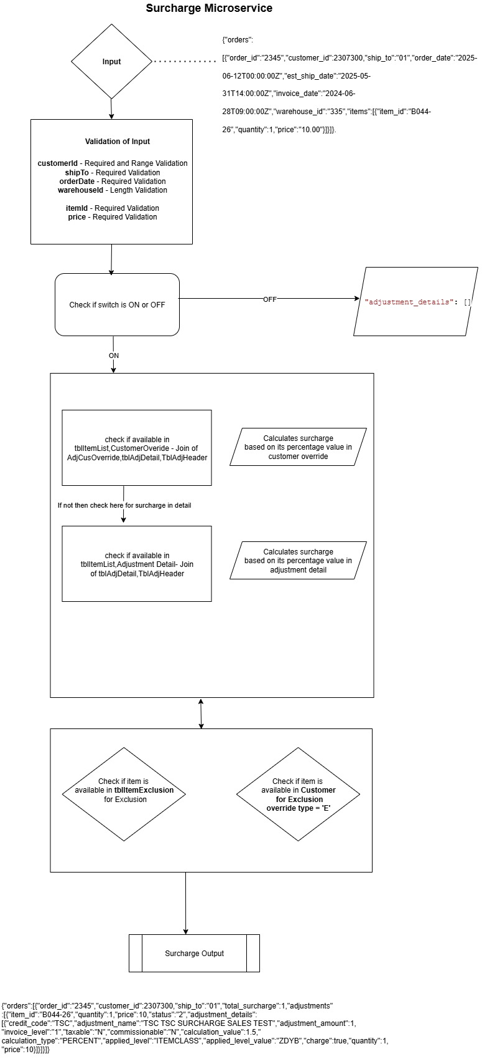

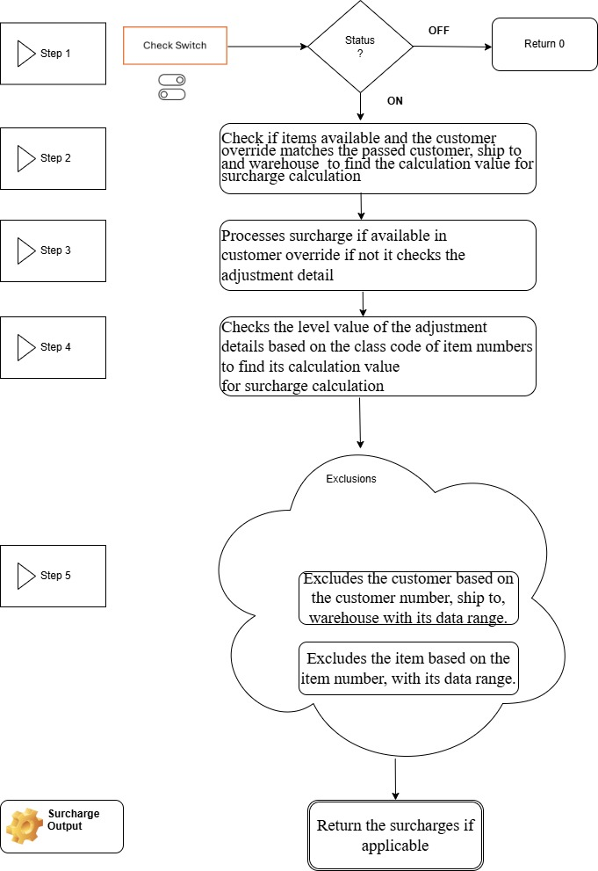
Data Sync Flow :

Adjustment UI Application:

Adjustment Header Page:

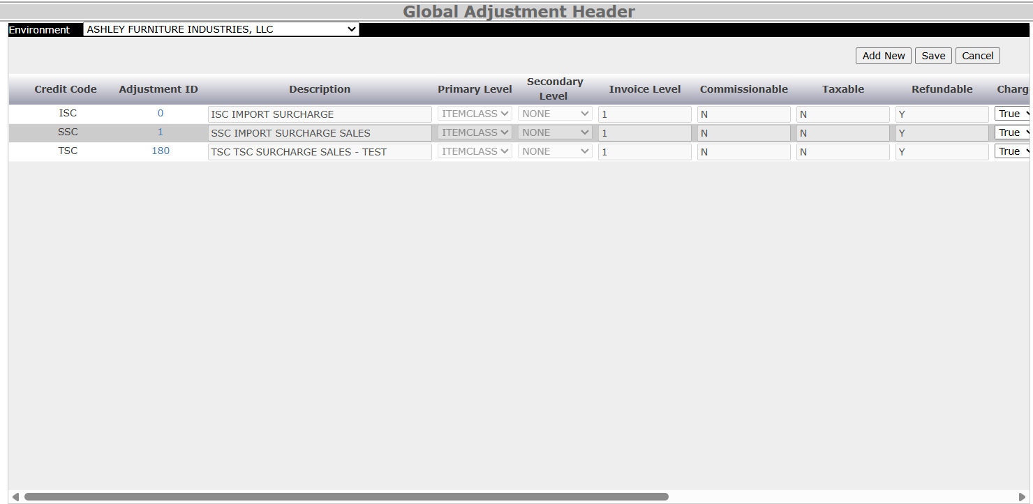

The Adjustment Header seems to encapsulate financial adjustments with fields like credit codes, charge/refund properties, and hierarchical levels. These fields are key to defining the behavior and classification of each adjustment.
Key Fields:
- AdjustmentId – Unique identifier
- CreditCode – Adjustment type or reason code
- Description – Display label for the adjustment
- PrimaryLevel, SecondaryLevel, InvoiceLevel – Categorization hierarchy
- Commissionable, Taxable, Refundable, Chargeable – Boolean flags defining financial behavior
Adjustment Header Page – AS/400 Integration for Credit Code Validation
The Adjustment Header interface is tightly integrated with Ashley Furniture's backend AS/400 system to ensure accuracy and data integrity during user interactions. A critical aspect of this integration involves validating the entered Credit Code against the centralized master data repository.

To accomplish this, the page dynamically invokes the following AS/400 web service endpoint:
http://afiqua.ashleyfurniture.com:10010/web/services/PRC_Get_Credit_Code_Info?crdno={creditNumber}

Adjustment Header Page – AS/400 Integration for Credit Code Validation
The Adjustment Header interface is tightly integrated with Ashley Furniture's backend AS/400 system to ensure accuracy and data integrity during user interactions. A critical aspect of this integration involves validating the entered Credit Code against the centralized master data repository.

To accomplish this, the page dynamically invokes the following AS/400 web service endpoint:
http://afiqua.ashleyfurniture.com:10010/web/services/PRC_Get_Credit_Code_Info?crdno={creditNumber}

Purpose and Flow
User Input: When a user enters a credit number on the Adjustment Header screen, the application triggers a request to the above AS/400 endpoint with the crdno query parameter representing the user-provided credit number.

Backend Validation: The AS/400 service responds with structured data regarding the credit code (e.g. validity, description, hierarchy levels, financial flags like chargeable/refundable).

Frontend Enforcement: The page uses this response to:

Confirm that the credit code exists and is valid.

Prevent users from submitting invalid or obsolete credit numbers.

Auto-populate related fields based on the returned data (e.g. description, levels, flags), minimizing manual input and ensuring consistency.

Update Support: Once a valid credit code is verified, users are allowed to update additional details tied to that code (such as commissionable or taxable flags), ensuring flexibility while preserving data authenticity.

Benefits
Data Reliability: Only verified credit codes are allowed, minimizing the risk of transactional errors or billing misclassifications.
Real-Time Synchronization: Ensures the web UI reflects the latest definitions and rules stored in the AS/400 system.

Maintainability: Centralized service enables future updates to credit code rules without requiring changes on the client side.User Input: When a user enters a credit number on the Adjustment Header screen, the application triggers a request to the above AS/400 endpoint with the crdno query parameter representing the user-provided credit number.
Backend Validation: The AS/400 service responds with structured data regarding the credit code (e.g. validity, description, hierarchy levels, financial flags like chargeable/refundable).
Frontend Enforcement: The page uses this response to:
Confirm that the credit code exists and is valid.
Prevent users from submitting invalid or obsolete credit numbers.

Auto-populate related fields based on the returned data (e.g. description, levels, flags), minimizing manual input and ensuring consistency.

Update Support: Once a valid credit code is verified, users are allowed to update additional details tied to that code (such as commissionable or taxable flags), ensuring flexibility while preserving data authenticity.

Benefits
Data Reliability: Only verified credit codes are allowed, minimizing the risk of transactional errors or billing misclassifications.

Real-Time Synchronization: Ensures the web UI reflects the latest definitions and rules stored in the AS/400 system.

Maintainability: Centralized service enables future updates to credit code rules without requiring changes on the client side.

Adjustment Detail Page:
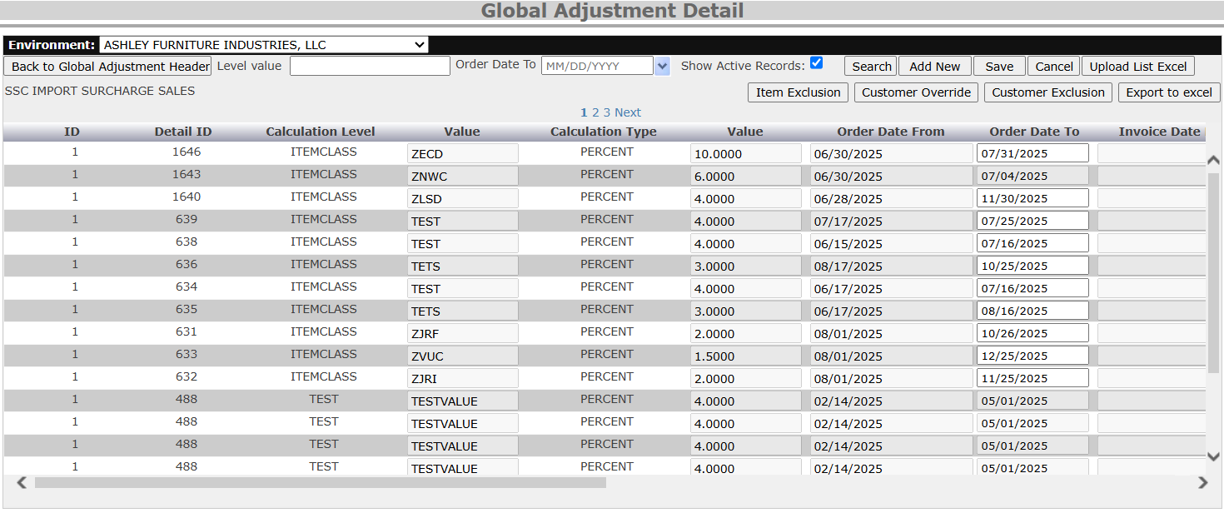

This interface manages fine-grained rules for surcharge adjustments at the item classification level. Each record is tightly coupled with a parent AdjustmentHeader (e.g., SSC Import Surcharge Sales) and defines conditions for calculating charges based on:
- DetailID: Unique record identifier
- CalculationLevel: Granularity of rule application (e.g., ITEMCLASS)
- Value: Classification code like ZECD, ZNWC, etc.
- CalculationType: PERCENT or FLAT
- Amount: Percentage or fixed surcharge
- OrderDateFrom/To: Eligibility window
- InvoiceDate: Optional field marking cutoff for invoicing

Adjustment Customer Override :

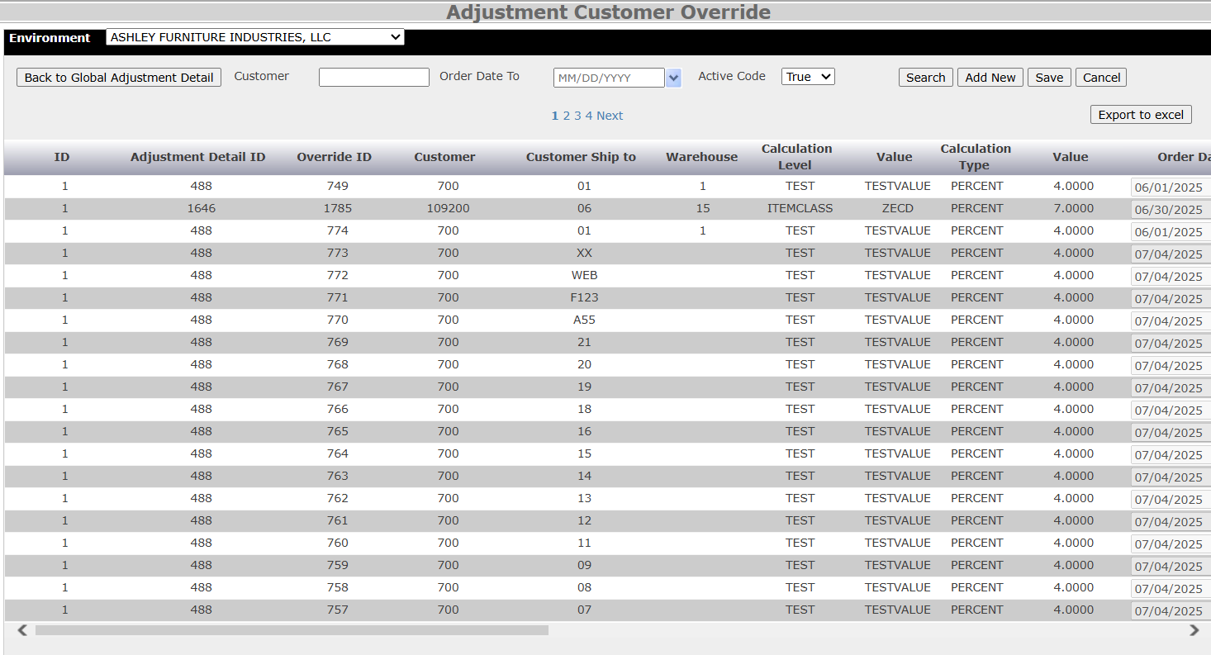

This module allows finance and operations teams to override standard surcharge adjustment rules per customer or ship-to location, ensuring flexibility for special accounts, warehouse routing, or exception handling.
The Customer Override UI page is built to maintain granular surcharge exception records on a per-customer basis. It plays a pivotal role in customizing how the surcharge microservice applies percentage-based charges for specific items, ensuring flexibility and precision in pricing logic.
This module allows the system to override standard adjustment rules with customer-specific surcharge percentages, tied to an item's classification and date constraints.
Surcharge Microservice – Processing Workflow
Here’s how the microservice incorporates customer overrides during its execution:

1. Item Parsing
For each order line, extract:

ItemNumber

CustomerId

ItemClassCode

OrderDate

2. Override Lookup
The microservice queries the CustomerOverride table to check if:
A record exists for the given CustomerId and ItemClassCode
The current OrderDate is within the specified date range
The AdjustmentDetailId maps to a valid AdjustmentHeader, which holds the actual CreditCode

3. Credit Code Mapping
Each override is indirectly linked to its CreditCode through:
CustomerOverride → AdjustmentDetail → AdjustmentHeader
This chain allows the microservice to validate the percentage override within the context of the business adjustment category.

4. Surcharge Decision
If a matching customer override exists:
Use the custom percentage from the override
If not:
Fallback to the default rule in AdjustmentDetail

Core Data Fields
- OverrideId Primary key for override record
- AdjustmentDetailId Reference to the surcharge rule being overridden
- CustomerId Target customer number
- CustomerShipTo Specific shipping destination for the customer
- Warehouse Logical or physical warehouse identifier
- CalculationLevel How adjustment is evaluated (e.g. ITEMCLASS, TEST)
- Value - Target classification (e.g. ZECD, TESTVALUE)
- CalculationType Type of surcharge (PERCENT / FLAT)
- Amount Surcharge amount
- OrderDate Effective start date for override
- IsActive - Status flag for soft deletion or archival

Item Exclusion:

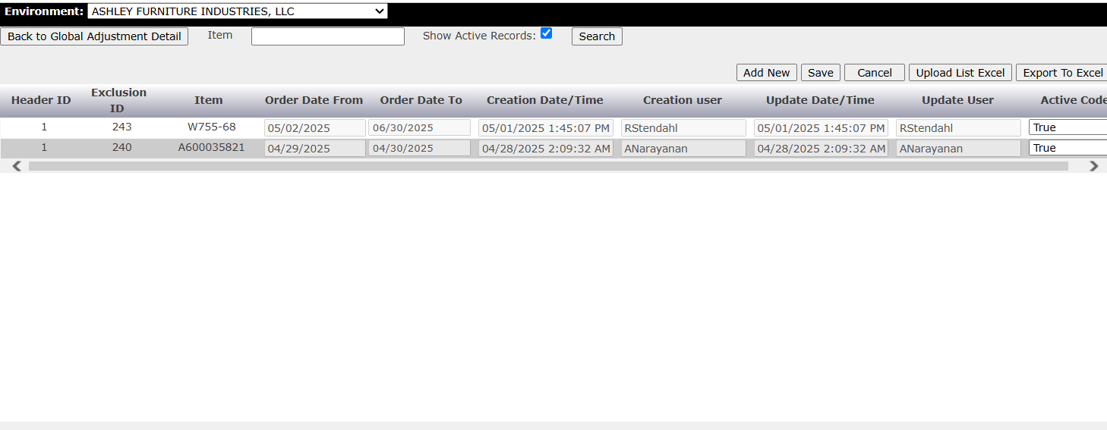

This module allows finance and operations teams to override standard surcharge adjustment rules per customer or ship-to location, ensuring flexibility for special accounts, warehouse routing, or exception handling.

Core Data Fields
- OverrideId Primary key for override record
- AdjustmentDetailId Reference to the surcharge rule being overridden
- CustomerId Target customer number
- CustomerShipTo Specific shipping destination for the customer
- Warehouse Logical or physical warehouse identifier
- CalculationLevel How adjustment is evaluated (e.g. ITEMCLASS, TEST)
- Value Target classification (e.g. ZECD, TESTVALUE)
- CalculationType Type of surcharge (PERCENT / FLAT)
- Amount Surcharge amount
- OrderDate Effective start date for override
- IsActive Status flag for soft deletion or archival

The Item Exclusion module is purpose-built to manage and enforce item-level exceptions in the Surcharge Microservice for Ashley Furniture. It serves as a control layer that ensures specific item numbers are excluded from surcharge calculations during invoice or order processing. The Item Exclusion feature is a critical submodule designed to enhance the accuracy and flexibility of Ashley Furniture’s Surcharge Calculation Microservice. It provides operational control over which item numbers should be excluded from surcharge computation—often for scenarios involving promotions, legacy SKUs, strategic partnerships, or internal test items.
This module plays a vital role in enabling business flexibility, allowing finance and operations teams to configure exceptions for promotional SKUs, legacy items, test data, or custom use cases without altering the core adjustment rule logic.
UI Capabilities & Functional Components
The user interface is designed to be intuitive, scalable, and secure, offering core features for data management, auditability, and high-volume control.
Search Functionality
Enables real-time lookup of excluded items by full or partial item number.

Supports filters such as:
- Header ID
- Order Date From / To
- Created By
- Active Code (to distinguish current exclusions)
- Ideal for reviewing and validating entries across distributed teams.

Upload Functionality
Users can upload bulk item exclusions via structured Excel or CSV templates.
Uploads typically contain:
- ItemNumber
- OrderDateFrom
- OrderDateTo
- ReasonCode (optional)

Backend processes and validates entries to prevent duplicates and ensure integrity.

📥 Export to Excel
- Downloads the complete or filtered exclusion list in Excel format.
- Useful for internal audits, external reviews, or backups.

Export includes metadata such as:
- Timestamps
- User actions
- Item status (Active Code)
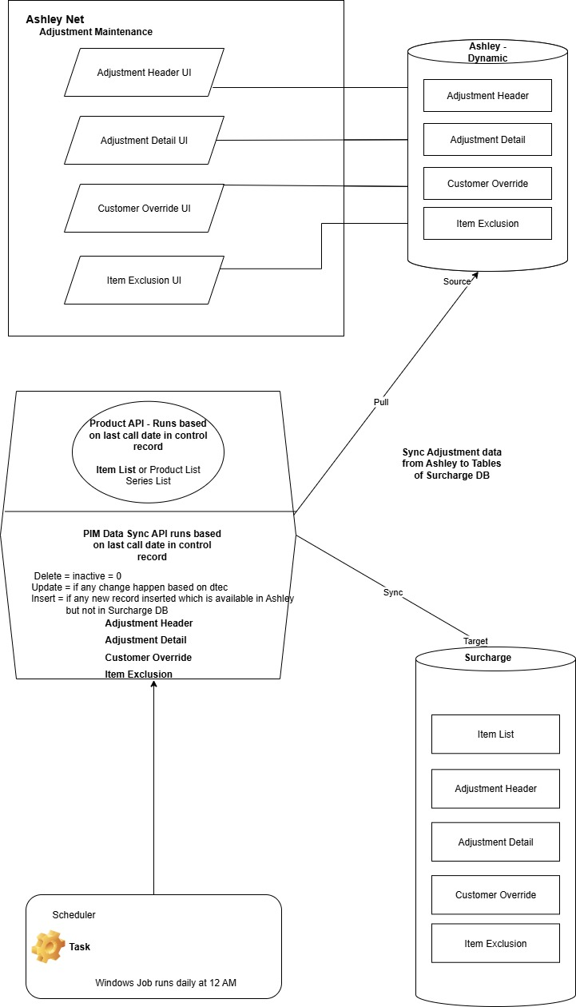

Name | Repo
Surcharge Microservice | https://ashleyfurniture@dev.azure.com/ashleyfurniture/  Financial%20Planning%20and%20Analysis/_git/Adjustment_Microservice
Windows Job PIM API | https://dev.azure.com/ashleyfurniture/Financial%20  Planning%20and%20Analysis/_git/Windows_Job_PIMAPI
PIM API | https://ashleyfurniture.visualstudio.com/Financial%20  Planning%20and%20Analysis/_git/Adjustment_PIMAPI

Microservice URL | Keys
https://devapigw.ashleyfurniture.com/surcharge  -microservice/orders | 224b086b55484e6b88ebceda0b000eb2
https://stageapigw.ashleyfurniture.com/surcharge-microservice/orders | 99bf2f7171164c408d5b4b91a7df4c65
https://apigw3.ashleyfurniture.com/  surcharge-microservice/orders | f562102e6c584cf2a852f8b051f4e863

DEV :

DB Server Name | aazeud-fnprsq01
SQL Account | s_ApiPriDBUserDev
Cluster | afi-dev-eastus-kube.ashleyfurniture.com
Namespace | finance
DNS CNAME: | adjustment-microservice.dev.finance.ashleyfurniture.com
TLS cert name | adjustment-microservice-tls
Managed Identity Name | afi-adjustment-microservice-api-dev-mi
Resource group | AFI-FINANCE-DEV-RG
Subscription | AFI DEV
Database Account
Applicaiton Insights | afi-surcharge-microservice-dev-ai

STAGE :
DB Server Name | AAZEUS-FNPRSQ01
SQL Account | s_ApiPriDBUserStage
Cluster | afi-stage-eastus-kube.ashleyfurniture.com
Namespace | finance
DNS CNAME: | adjustment-microservice.stage.finance.ashleyfurniture.com
TLS cert name | adjustment-microservice-tls
Managed Identity Name | afi-adjustment-microservice-api-stage-mi
Resource group | AFI-FINANCE-DEV-RG
Subscription | AFI STAGE
Database Account
Applicaiton Insights | afi-surcharge-microservice-stage-ai

PROD:

DB Server Name | AE1DCVPSQ23766
SQL Account | s_ApiPriDBUserPROD
Cluster | afi-prod-eastus-kube.ashleyfurniture.com
Namespace | finance
DNS CNAME: | adjustment-microservice.prod.finance.ashleyfurniture.com
TLS cert name | adjustment-microservice-tls
Managed Identity Name | afi-adjustment-microservice-api-prod-mi
Resource group | AFI-FINANCE-DEV-RG
Subscription | AFI PROD
Database Account | connected through SQL account of ashleyfurniture\s_ApiPriDBUserProd
Applicaiton Insights | afi-surcharge-microservice-prod-ai

Change Request with respect to Surcharge Project:
Change Request | Description
CHG0038903 | Implementation of Adjustment microservice for surcharge project
CHG0039158 | Implementation of Adjustment microservice for surcharge project
CHG0041582 | Implementation of PIM Product Data API for Adjustment microservice
CHG0041919 | Configuring the windows job to update the PIM Product Details
CHG0043438 | Implementation of Adjustment microservice on Kubernetes and Adjustment Details API for surcharge project
CHG0043667 | Production promote of Adjustment UI Changes in Ashley Net Application
CHG0043746 | Production promote of PIM API and windows job scheduler

Appendixes

Glossaries
- TWN: The Work Number (An automated employment and income verification service from Equifax)
- UC: Unemployment Compensation
- ACA: Affordable Care Act
- UKG: Ultimate Kronos Group (A provider of human capital management (HCM) solutions)
- ADP: Automatic Data Processing (A provider of human resources management software and services)
- BI: Business Intelligence (Refers to technologies, applications, and practices for collecting, integrating, analyzing, and presenting business information)
- SFTP: Secure File Transfer Protocol (A secure method for transferring files between systems over a network)
- HTTPS: Hypertext Transfer Protocol Secure (A secure version of HTTP, the protocol used for transferring data over the internet)
- FTP: File Transfer Protocol (A standard network protocol for transferring computer files between a client and server on a network)
- DL: Distribution List (Refers to an email distribution list for notifications)
- UAT: User Acceptance Testing (The final phase of software testing where actual users validate and accept the system)
- CST: Central Standard Time
- AFI: Ashley Furniture Industries

